**DNOR - DriveNets Network Orchestrator**

Bringing the simplicity and visibility of cloud orchestration to Network Cloud

WHITE PAPER

# Operational Challenges

From Core to Edge to 5G, open software-based disaggregated networks, running on white boxes are on the rise. Service and cloud providers are looking to scale their networks, reduce their costs and accelerate innovation, and are willing to try new network solutions that can get them there. AT&T, for example, has already transformed its core network with DriveNets Network Cloud solution – the first implementation of a Distributed Disaggregated Chassis (DDC) design that AT&T contributed to the Open Compute Project (OCP). Vodafone and Telefonica are among other public advocates of the disaggregated network model and have announced the deployment of disaggregated cell site gateways (DCSG) through Telecom Infra Project (TIP). And there are more service and cloud providers who are involved in disaggregated networking efforts.

While this new disaggregated network model brings significant scale and cost benefits, it also raises concerns regarding its operational model. Unlike traditional monolithic router chassis that a single vendor sells as an integrated solution, the components of the disaggregated network are sold by multiple vendors, each providing its part. This model is new to service providers who fear the extra complexity associated with the orchestration, and management of the open model, particularly in the areas of field installation, upgrades, capacity growth, and troubleshooting.

Similar to cloud orchestration solutions, DriveNets Network Orchestrator (DNOR) brings the cloud’s operational simplicity, automation and visibility to Network Cloud, and helps accelerate the deployment of cloud-native networks. DNOR provisions DriveNets Network Cloud’s hardware and software components coming from the different vendors by composing a singleentity routing solution that can scale from a single white box hardware to hundreds of white boxes with cloud-native software running on top of it.

With DNOR, DriveNets Network Cloud gains the operational integration of monolithic routers while maintaining the cost and scale benefits of the disaggregated architecture. Its orchestration can extend across clusters and even to third-party service elements.

# DriveNets Network Orchestrator (DNOR)

DriveNets Network Orchestrator (DNOR) is an orchestration system designed to automate the deployment, scaling, and management of the DriveNets Network Cloud solution. DNOR simplifies deployment and management, and provides added visibility into cloud resources and hosted services across the entire Network Cloud infrastructure. It manages the infrastructure life cycle, including the provisioning, upgrade, configuration and troubleshooting of DriveNets Network Operating System (DNOS) as well as the networking and third-party services running on top of it.

DNOR offers detailed insights on the system internal architecture from the hardwarecomponent to the software container, KPIs relating to SLA, alarm and fault management, including network-wide fault correlation and automated root cause analysis, with suggested corrective actions to perform rapid fixes. These insights improve reliability and availability and reduce operating costs, relative to traditional monolithic routers.

Unlike traditional network orchestration and management systems, DNOR is not an afterthought solution but a central component of the DriveNets Network Cloud solution. Like DNOS, DNOR is built on a microservices and containers-based architecture offering flexibility and scale.

DNOR runs on a private or public cloud infrastructure and is used to manage the production environment within a secure and controlled domain.

*Operations dashboard*

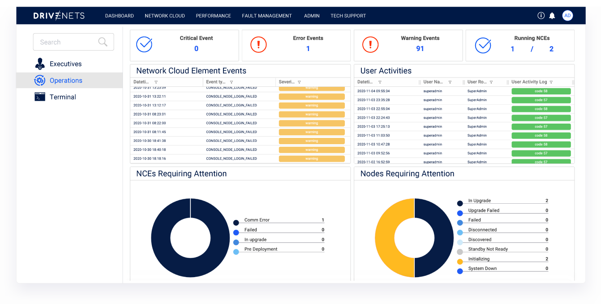

# Key Capabilities

## Automated operations

This includes the lifecycle management of DriveNets Network Cloud’s resources and services – from provisioning to decommissioning, including:

Zero-touch provisioning – automatically integrates multi-vendor white box hardware and DNOS software into a working routing solution. It supports a secure, error-free deployment with minimum manual intervention. Prior to entering the secure and controlled operator network’s environment, white boxes undergo a secure initialization process managed by G-DNOR, DriveNets’ multi-tenant, pre-provisioning system running on the public cloud, and operated by a reseller or value-added reseller (VAR).

*The white box journey to a working node entity*

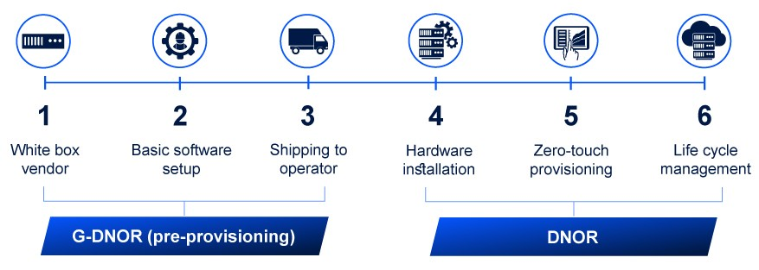

1. The VAR receives the new boxes from the ODM supplier. As an extra security measure, the VAR can wipe the vendor’s software off the boxes with DriveNets secure bootstrap.
2. The boxes connect to G-DNOR. Once they are authenticated, the base OS software is downloaded according to box type.
3. The VAR sends the boxes to the service or cloud provider and physically mounts them in the provider’s network.
4. The orchestrator creates the cluster and provisions its controller (NCC).
5. The NCC automatically discovers the boxes and provisions them with the correct DNOS version based on their profile.
6. The cluster is managed as a single entity throughout its life cycle, its internal components being managed by DNOR.

Consistent single entity management – any Network Cloud deployment, whether based on a standalone white box or a cluster of white boxes, is managed in the same way - as a single entity, independent of its topology, size or location.

*Single entity view*

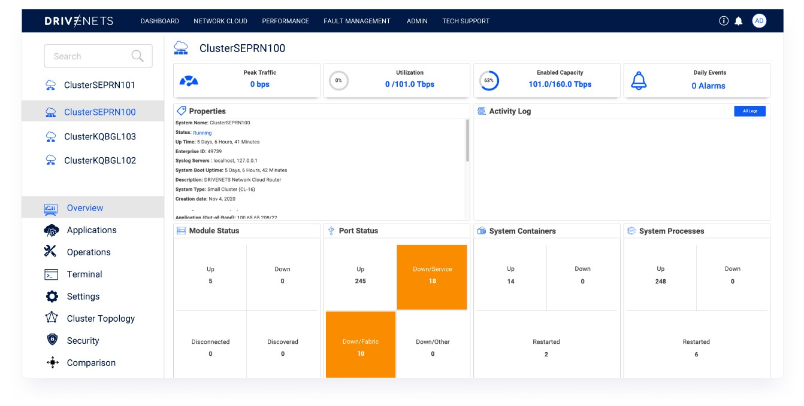

Hardware inventory management – provides detailed information on every network cloud element and its components, including location, model, and device status.*Hardware inventory view*

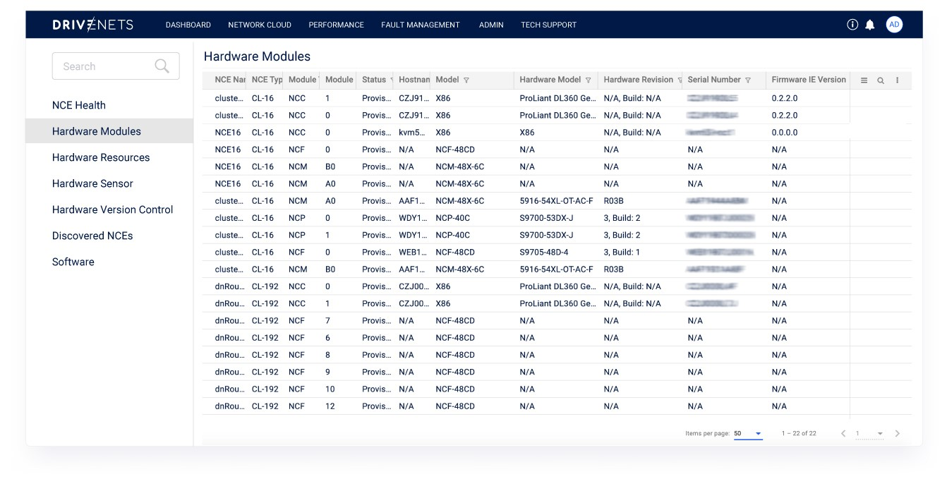

Automated scale-up and scale-down – a new white box added to a Network Cloud cluster is automatically provisioned and enabled gracefully without service impact or downtime. Likewise, removing a white box from the cluster is also done seamlessly.

*Automated scale-up*

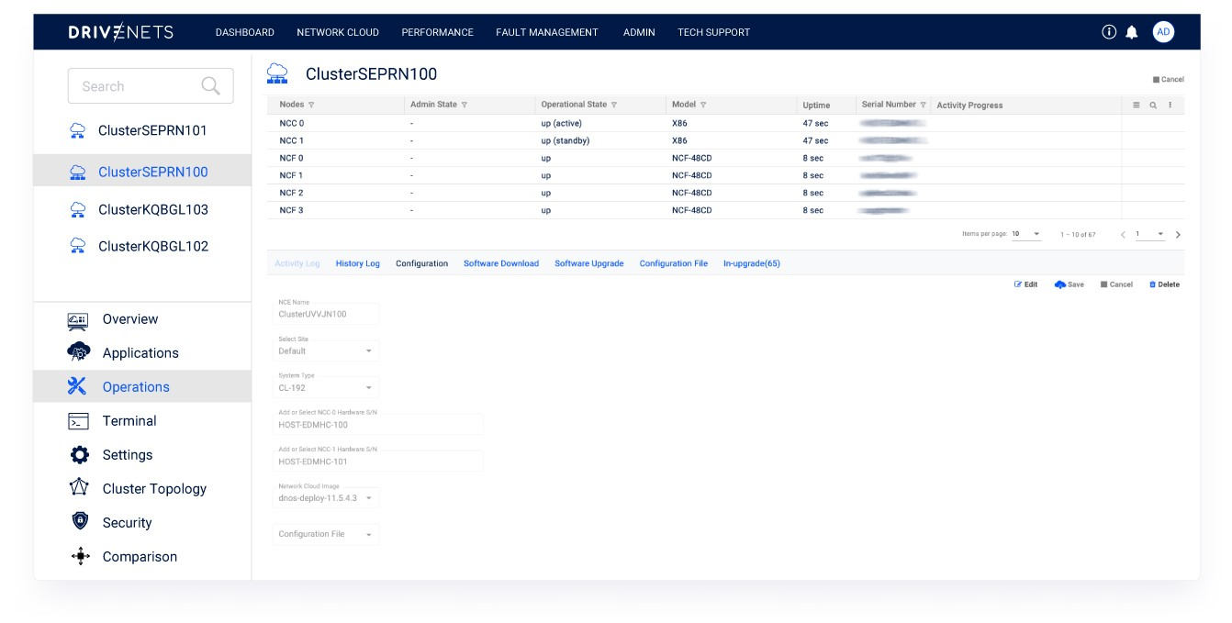

Modular software orchestration – covers the entire stack and can be done selectively per specific software component, including firmware, base OS, NOS image/container, and hosted service, across nodes, clusters and the entire network, supporting:

* Software signature
* Hardware/software integrity verification
* Modular download, installation and upgrade per component
* Real-time orchestration status
* Scheduled automated tasks and processes
* Installation rollback
* Parallel installation across and within clusters
* Container orchestration: automatic scaling and failovers, self-healing, optimal utilization of cluster resources

*Software orchestration – activity view*

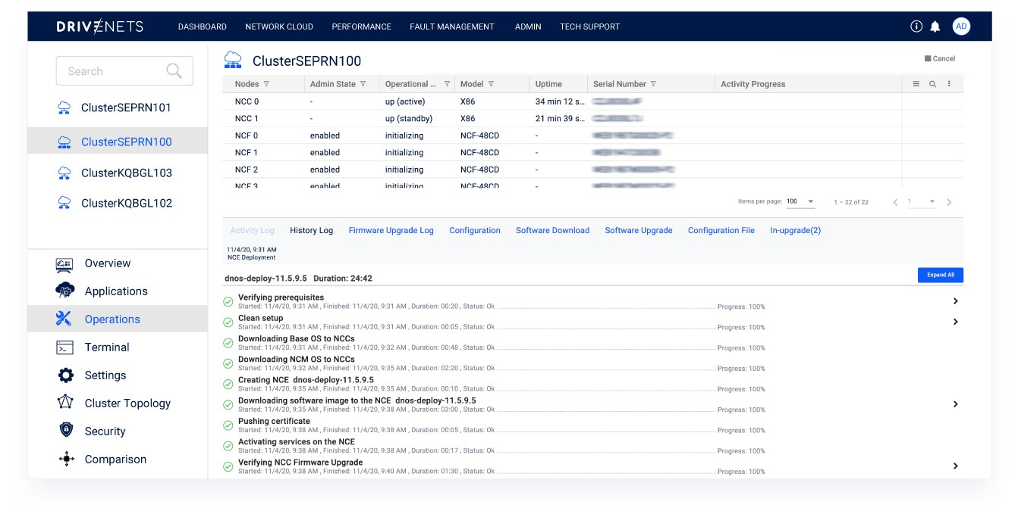

## Multi-service orchestration

DNOR automates the deployment, scaling, management of networking and third-party services hosted on the shared Network Cloud infrastructure, such as:

* Easy onboarding of certified third-party services
* Different hosted services running in microservices and separate containers
* Required resources, scale, and QoS parameters per service or network element
* Standard, open northbound interfaces (Rest APIs, AAA…) for third-party service integration and end-to-end system management (orchestration, inventory, OSS/BSS, data warehouse/analytics)

*Hosted multi-services – application onboarding*

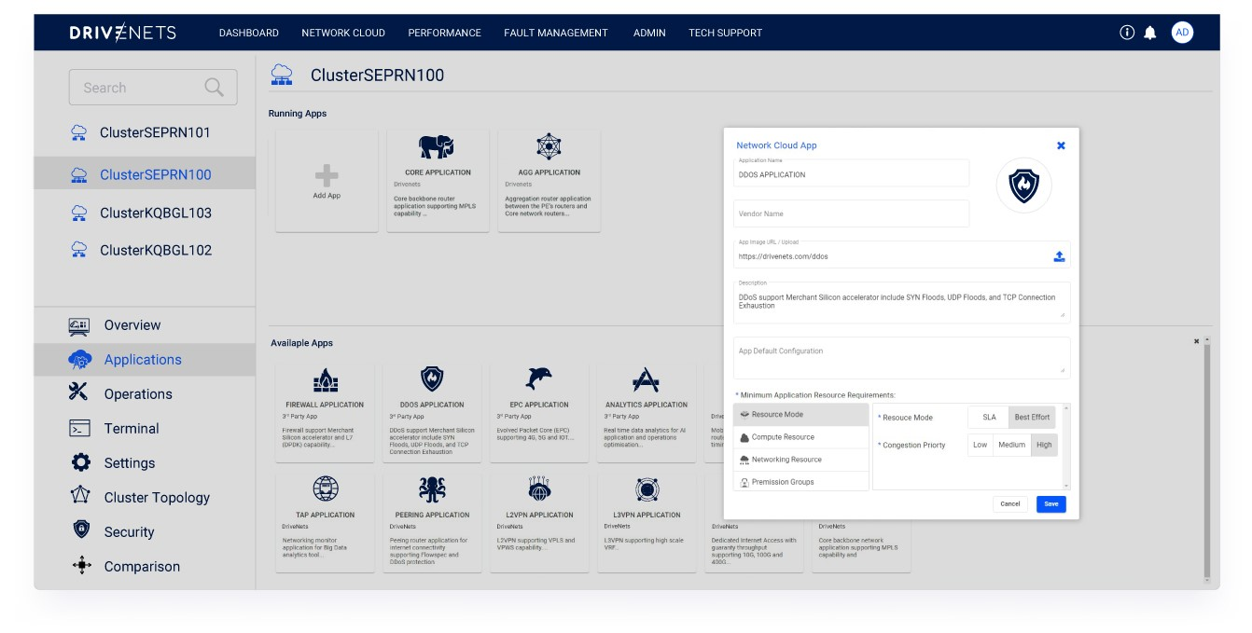

DNOR provides a live view of the containerized applications hosted on the shared Network Cloud infrastructure, including the resources used and the state of the processes running inside them.

*Hosted multi-services – containerized application view*

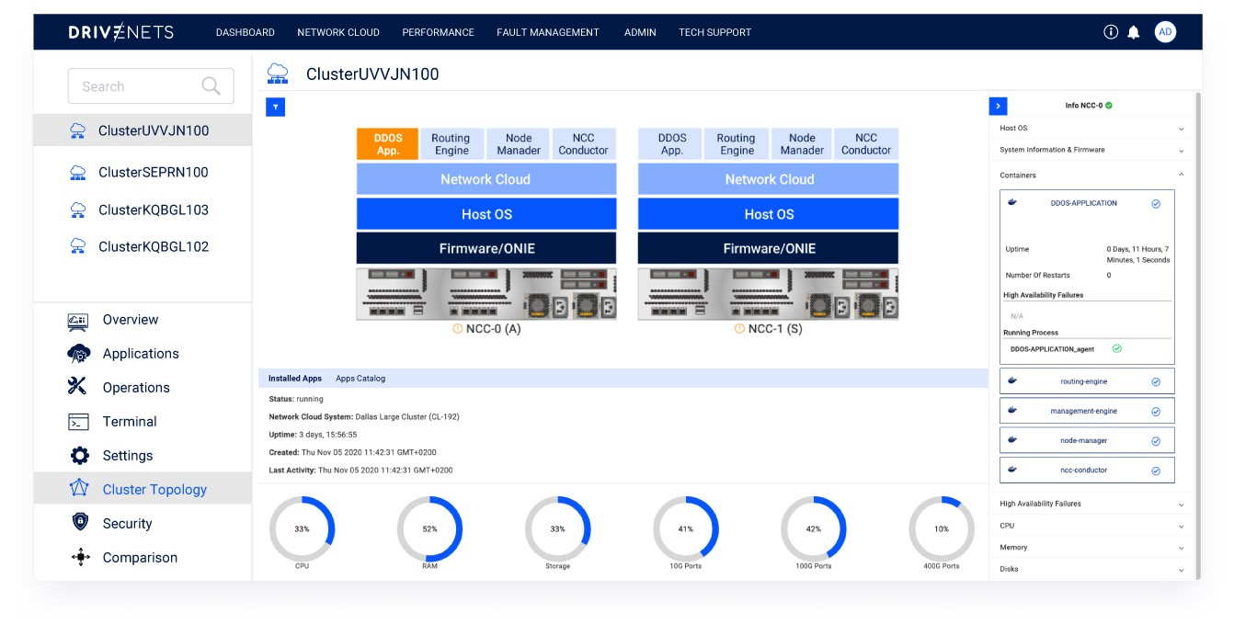

## Health monitoring and assurance

DNOR automates event and KPI monitoring and ensures availability and performance SLAs (cluster to network-level) such as:

Cluster topology – live view of the cluster’s nodes, their states, formation and connectivity across clusters and the entire network, including:

* Hardware components: CPU, memory, fan, temperature, ports, and interfaces
* Software components: base OS, firmware, processes, containers, and microservices

*Cluster topology view*

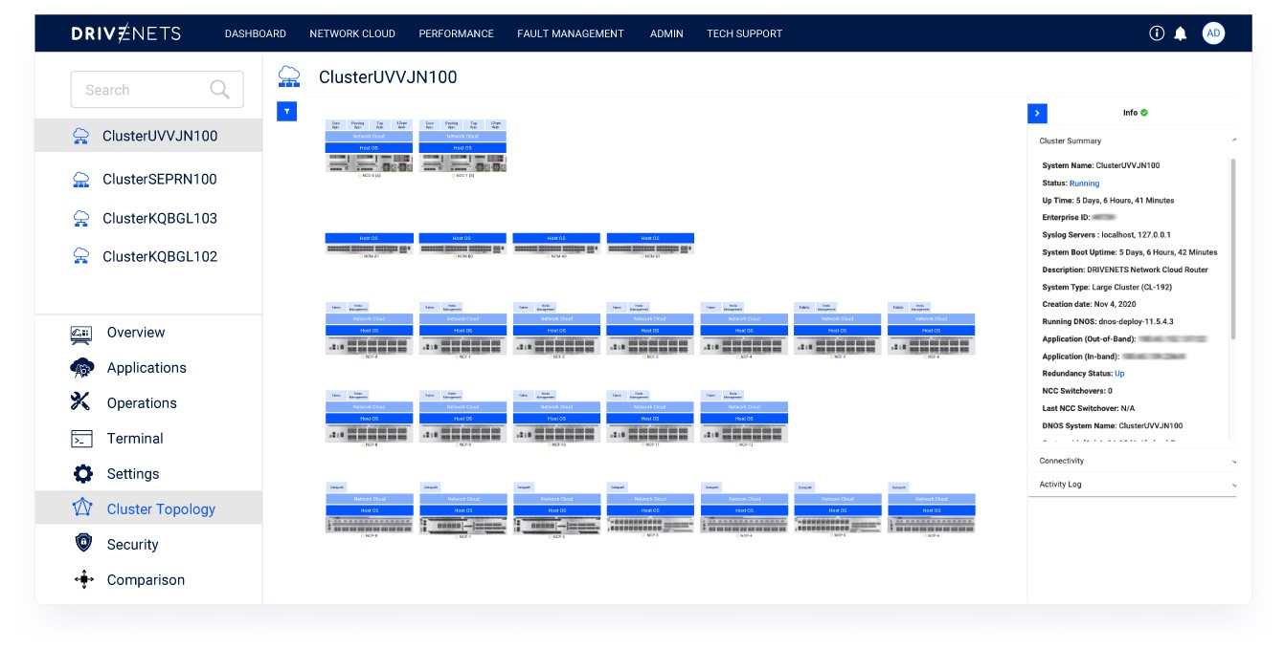

Fault, performance, and alarm management

* Supports alarms and KPIs at every level of the system – from hardware components to software containers and services across nodes, clusters, and network
* Based on aggregation and cross-reference of multiple data sources (hardware, system, traffic counters, and more)
* Supports out-of-box KPIs
* Alarm dashboard to monitor and categorize system alarms
* Automated alarm filtering and correlation – including performance KPIs for proactive/reactive fault and performance management
* Automated root cause analysis
* Real-time and time-series alarm view
* User-defined alarms

*Time-series alarm view*

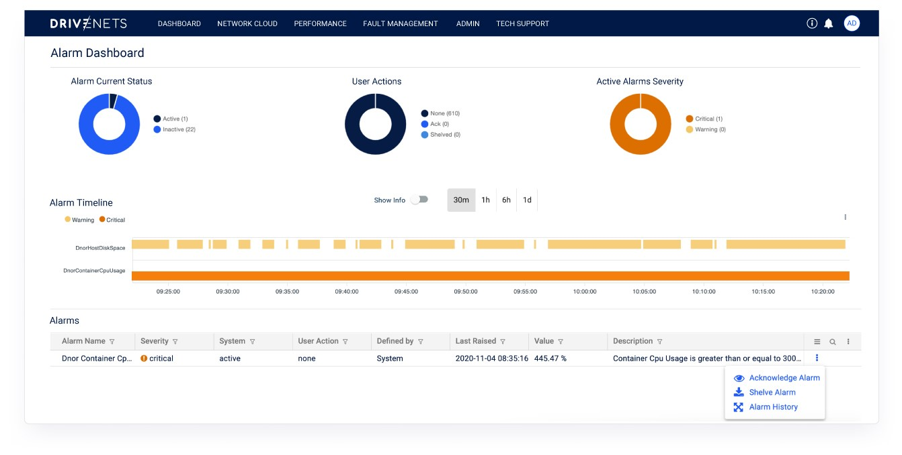

* Tech support integration for in-depth system diagnosis and debugging
* Easy log file management – generation, view, export, and download
* CLI integration
* Screen recording and sharing
* Support of scripting and macros

*Tech support CLI integration*

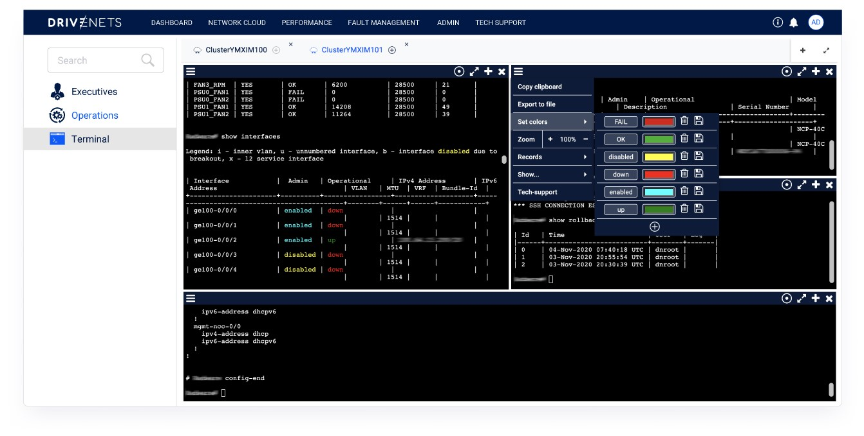

# Architecture

DNOR interfaces with DNOS using open protocols (gRPC/gNMi, Netconf/Yang, SaltStack) and comprises the following functional blocks:

*DNOR high-level architecture*

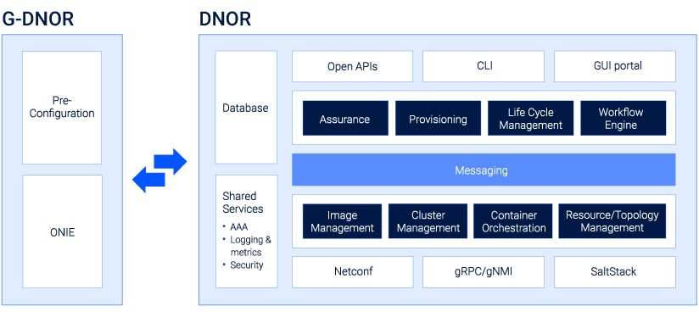

# Business and Technical Benefits

DNOR turns the DriveNets Network Cloud promise into a reality. It offers a full network life cycle management that is automated, transparent, and simpler to manage than any traditional router, drastically reducing OpEx.

DNOR delivers the following benefits:

## Simplified operational model - orchestrating the open disaggregated network like hyperscalers orchestrate the cloud

DNOR simplifies the provisioning and management of the Network Cloud model. It takes care of the initial integration between different vendors, provides seamless management of all moving parts (hardware and software), and solves the troubleshooting and support issues between the different suppliers. DNOR preserves the convenience of single ownership for network provisioning, assurance, and support.

## Reduced maintenance windows

Unlike incumbent solutions, DNOR offers a fully transparent, modular, scalable software orchestration experience for downloads, patches, and upgrades that apply to individual software stack components (firmware, base OS, specific NOS containers, or hosted services), across the entire network. Its modularity circumvents the lengthy and inefficient process of managing monolithic software. The granular visibility helps to pinpoint potential issues and act quickly on them. Combined, they can help reduce maintenance windows from hours to potentially minutes.

## Increased network availability, performance, and reliability

While DNOR’s container-level orchestration improves reliability with auto-scale, failovers, and self-healing, the combination of granular visibility and smart insights accelerates troubleshooting and debugging, reducing MTTR (Mean-Time-To-Resolution) and increasing network availability and performance.

## Faster services time-to-revenue

As a service-aware orchestration system, DNOR accelerates services time-to-revenue by quickly deploying and scaling Network Cloud’s hosted network services like routing, 5g, or edge services on the shared Network Cloud infrastructure, just like the cloud with third-party services running on the shared compute and storage infrastructure.

## Lowest OpEx model

DNOR’s end-to-end automation, transparency, and network insights associated with containerized microservices-based DriveNets Network Cloud Operating System (DNOS) are the perfect combination to deliver the lowest network operational costs in the market today with:

* Rich process automation – inspired by the cloud, adapted to complex distributed disaggregated network environments
* Simplified operation – clusters managed as a single entity
* Reduced service assurance expenses with network simplification and standardization
* Reduced security, certification, and software upgrade expenses
* Decouples network growth from operational costs while the skillset required for operation is less specialized and easier to obtain



ABOUT DRIVENETS

DriveNets is a fast-growing IP networking software company, introducing a radical new way to build

networks for service and cloud providers, enabling higher capacity and services to scale with greater agility,

at a much lower cost. Founded by Ido Susan and Hillel Kobrinsky, two successful telco entrepreneurs,

DriveNets Network Cloud is the leading open distributed disaggregated routing solution based on cloud-

native software and standard white boxes, that disaggregates the network from core to edge, building the

distributed network of the future. For more information, visit us at

**www.drivenets.com**

# Conclusion

As open, software-based disaggregated network architectures in general and DriveNets Network Cloud in particular are gaining interest, their operational model often raises concerns about its ease of deployment, maintenance, and support, and the overall responsibility of the solution vendors.

DNOR simplifies and automates Network Cloud’s operations and management making them as simple as the cloud while keeping the convenience of a single-vendor management entity. DNOR is the modern orchestration system of the new network model, Network Cloud.